DISCLAIMER
This Request For Proposal is provided for general informational purposes, may not apply to your city's specific situation and should not be considered a comprehensive RFP. It should be used for comparative purposes only. The RFP should be tailored to reflect the actual context of your city. You should consult with your city attorney before taking any action based on this document.

Request for Proposals

Structure Demolition and Site Stabilization

for

A Single Family Home

Located At 146 Norris St
Decatur, Georgia 30030

Owner:

City of Decatur
509 North McDonough Street
P. O. Box 220
Decatur, Georgia 30031

January 8, 2018

Project Description

This Request For Proposals (RFP) is for the demolition of a single family residence located at 146 Norris St, Decatur, GA 30030,

Scope of Work

The Scope of Work shall include all labor, transport, and materials to complete the hazardous materials survey and abatement, septic system tank removal and absorption field abandonment, demolition and disposal of structures, demolition of site features for the single family dwelling located at the following address:
1. 146 Norris St, Decatur, GA, 30030

All Work shall be completed in accordance with the reports, drawings and specifications attached to this document.

TABLE OF CONTENTS

ITEM PAGE NUMBER

Notice to Bidders NTB-1
Instructions to Proposers IP-1 to IP-3
Non-Collusion Affidavit NC-1
Proposal P-1 to P-3
Agreement A-1 to A-2
General Conditions GC-1 to GC-9
Special General Conditions SGC-1 to SGC-4
E-Verify & SAVE Requirements E-1 to E-4

Plans and Specifications 1. Demolition Site Plan: 146 Norris
Street.
- Construction Entrance Detail
- Tree Protection Fence Detail
- Section 02050 – Demolition of
Structures
- Tank Inspection Form

NOTICE TO BIDDERS

The City of Decatur will receive sealed bids on 11:00 am, January 31, 2018 for the structure demolition at 146 Norris St. Decatur, GA, 30030, in the City Commission Room at Decatur City Hall, 509 North McDonough Street, Decatur, Georgia, 30030, at which time and place all bids will be publicly opened and read aloud. This work includes structure demolition, hazardous materials abatement, and site stabilization

The proposals must be delivered by the deadline to the City Manager’s Office on the 2nd Floor of Decatur City Hall, (509 North McDonough Street, Decatur, GA 30030) and shall be marked “Structure Demolition at 146 Norris St” . The bidder must submit three (3) copies of their proposal with one marked original.

A pre-bid conference is scheduled on-site starting at 11:00 a.m. on January 17, 2018. The Meeting will be held at the project site at 146 Norris St, Decatur, GA, 30030. Any questions regarding bids and/or misunderstandings that may arise from this proposal should be submitted, in writing, and should be directed to Mark A. Ethun, AIA, Building Official, at 678553-6508 or at mark.ethun@decaturga.com, no later than 12:00 noon on January 24, 2018.

The Contract Documents for this project are available on-line at no charge at www.decaturga.com/requestforproposals.

The Contractor must ensure that employees and applicants for employment are not discriminated against because of their gender, race, color, genetic information, religion, national origin, political affiliation, age, handicapped status, sexual orientation, sexual preference, or gender identity and expression.

Proposals will be considered only from experienced and well-equipped contractors. Prior to beginning construction, the successful bidder will provide a complete Agreement package and a certificate of insurance. The City reserves the right to reject any or all bids or to waive informalities in the bidding.

Bids may be held by the City for a period not to exceed sixty (60) days from the date of the opening of bids for the purpose of reviewing the bids and investigating the financial stability of the bidders and their demonstrated ability to perform satisfactorily, prior to awarding the contracts.

NTB-1

INSTRUCTIONS TO PROPOSERS

1. EXAMINATION OF SITE AND CONTRACT DOCUMENTS

(a) Proposers shall inform themselves of all conditions under which the work is to be performed, concerning the site of the work, the structure of the ground, the obstacles which may be encountered, whether shown in the Contract Specifications or not, and all other relevant matters concerning the work to be performed.

A Contractor to whom a contract is awarded will not be allowed any extra compensation by reason of any such matters or things concerning which the Contractor did not inform himself prior to proposing. The successful Contractor must employ, as far as possible, such methods and means in the carrying out of this work as will not cause any interruption or interference with any other Contractors.

- Proposers must satisfy themselves by personal examination of the locations of the proposed work and by such other means as they may prefer locations of the proposed work and by such other means as they may prefer as to the correctness of any quantities listed in the proposal, and shall not, after submission of their proposal, dispute or complain of such estimate nor assert that there was any misunderstanding in regard to the nature or amount of work to be done.

- Before submitting a proposal, each Proposer shall examine carefully the complete Contract
Documents, including but not limited to Instructions to Proposers, Non-Collusion Affidavit, General Conditions, Special Conditions, the Form of Agreement and Bonds (if any), Plans and Specifications and all Addenda thereto, all of which contain provisions applicable not only to the successful Proposer but also to any of his subcontractors.

- Each proposer is expected to base his proposal on materials and equipment complying fully with the Contract Specifications, and in the event he names or includes in his proposal, materials or equipment which do not conform he will, if awarded a contract, be responsible for furnishing materials and equipment which fully conform at no change in his contract price.

Proposer hereby certifies that ____________________________________________, a (Name)

duly qualified representative of ___________________________________________,
(Firm Name)

inspected all job locations on _______________________________________________.
(Fill in Dates)

2. INTERPRETATION OF CONTRACT DOCUMENTS

If any person contemplating submitting a proposal on this project is in doubt as to the true meaning of any part of the Contract Specifications or other Sections of the Contract Documents, he may submit to the Owner a written request for an interpretation thereof. The person submitting the request will be
responsible for its prompt delivery. Any interpretation of the Contract Documents including the Contract Specifications will be made only by addendum duly issued or delivered by the Owner to each person receiving a set of such documents. The Owner will not be responsible for any other explanations or interpretations of the Contract Documents including the Contract Specifications.

IP-1

3. APPROXIMATE QUANTITIES

On all items on which proposals are to be received on a unit price basis the quantities stated in the Proposal will not be used in establishing final payment due the Contractor. The quantities stated on which unit prices are so invited, are approximate only, and each proposer shall make his own estimate from the Contract Specifications of the quantities required on each item and calculate his unit price proposal for each item accordingly. Proposals will be compared on the basis of number of units stated in the Proposing Schedule set forth in the Proposal. Payment on the contract on unit price items will be based on the actual number of units installed on the completed work. Lump Sum proposal items shall be supported by a Schedule of Values as established in the Contract Specifications.

4. SIGNING OF PROPOSALS

If the proposer is a corporation, the legal name of the corporation shall be set forth together with the signature of the officer or officers authorized to sign contracts on behalf of the corporation; if proposer is a co-partnership, the true name of the firm shall be set forth together with the signatures of all the partners; and if proposer is an individual, his signature shall be inscribed. If signature is by agent, other than an officer of a corporation or a member of a partnership, a power of attorney must be on file with the Owner prior to opening proposals or submitting proposals; otherwise, the proposal may be disregarded as irregular and unauthorized.

5. QUALIFICATION OF PROPOSERS

It is the intention of the Owner to award a contract only to a proposer who furnishes satisfactory evidence that he has the requisite experience and ability and that he has sufficient capital, facilities and plant to enable him to prosecute the work successfully and promptly, and to complete the work within the time named in the Contract Documents.

To determine the degree of responsibility to be credited to a proposer, the Owner will weigh any evidence that the proposer or personnel guaranteed to be employed in responsible charge of the work has or has not performed satisfactorily on other contracts of like nature and magnitude or comparable difficulty at similar rates of progress.

6. DISQUALIFICATION OF PROPOSERS

More than one proposal for the work described in this Document, to be included under a Contract, from an individual, firm or partnership, a corporation or an association under the same or different names, will not be considered. Reasonable grounds for believing that any proposer is interested in more than one proposal for the work contemplated will cause the rejection of all proposals in which such proposer is interested. If there is reasonable grounds for believing that collusion exists among the proposers, the proposals of the participants in such collusion will not be considered.

7. AGREEMENT, BONDS, INSURANCE

The attention of proposers is specifically directed to the forms of agreement and bonds to be executed and types of insurance to be taken out in the event a contract award is made.

IP-2

8. FAILURE TO EXECUTE AGREEMENT AND FILE REQUIRED BONDS AND INSURANCE

Failure of a successful proposer to execute the agreement and file required bonds and insurance within the required time shall be just cause for the annulment of the award. On failure of a successful proposer to execute the agreement and file the required bonds and insurance within the required time, he shall forfeit his proposal security as agreed as liquidated damages, and the proposer, by filing a proposal, agrees to this proviso. Upon annulment of an award as aforesaid, the Owner may then award a contract to the next lowest responsible proposer.

9. AWARD OF BID

It is the intent of the owner to award a contract to the lowest qualified proposer provided the bid has been submitted in accordance with the bidding documents and does not exceed the funds available. The Owner shall have the right to reject any or all bids and to waive informalities and irregularities in a bid and to accept the bid which, in the Owner’s judgement, is in the Owner’s best interests. The Owner shall have the right to accept Alternates in any order or combination and to determine the low proposer on the basis of the Base Bid and Alternates accepted.

10. PROPSALS

Proposals shall include the following forms properly executed by the Proposer:

Instructions to Proposers Form
Proposal for Construction
Non-Collusion Affidavit
Special General Conditions Form
E-Verify Forms

IP-3

NON-COLLUSION AFFIDAVIT OF PRIME BIDDER

State of ______________.
County of ______________.

______________________________________, being first duly sworn deposes and says that:

- He/She is ______________________________________________ of
(owner, partner, officer representative, or agent)

_____________________________________________, the Bidder that has submitted the attached Bid;

- He/She is fully informed respecting the preparation and contents of the attached Bid and of all pertinent circumstances respecting such Bid;

- Such Bid is genuine and is not collusive or sham bid;

- Neither the said Bidder nor any of its officers, partners, owners, agents, representatives, employees or parties in interest, including this affiant, has in any way colluded, conspired, connived or agreed, directly or indirectly, with any other Bidder, firm or person to submit a collusive or sham Bid in connection with the Contract for which the attached Bid has been submitted or to refrain from bidding in connection with such Contract, or has in any manner, directly or indirectly, sought by agreement or collusion or communication or conference with any other Bidder, firm or person to fix the price or prices in the attached Bid or of any other Bidder, or, to fix any overhead, profit or cost element of the bid price or the bid price of any other Bidder, or to secure through any collusion, conspiracy, connivance or unlawful agreement any advantage against the City of Decatur, Georgia or any person interested in the proposed Contract; and

- The price or prices quoted in the attached Bid are fair and proper and are not tainted by any collusion, conspiracy, connivance or unlawful agreement on the part of the Bidder or any of its agents, representatives, owners, employees, or parties in interest, including this affiant.

Signed: ________________________________

________________________________
(Title)
Subscribed and sworn to before me
this ________day of ______________, 20____

______________________________________
Notary Public
My commission expires _____________________ .

NC-1
PROPOSAL
STATE OF GEORGIA,
COUNTY OF DeKALB
PROPOSAL OF:
_________________________________________
_________________________________________

TO THE CITY MANAGER OF THE CITY OF DECATUR, GEORGIA:

The undersigned, as contractor, hereby submits this proposal for

Demolition for
A Single Family Home Located at 146 Norris St.
Decatur, Georgia, 30030

The contractor has made a personal examination of the site of the proposed work and proposes and agrees that if this proposal is accepted to provide the necessary labor, machinery, tools, apparatus, equipment and all things necessary to complete the work in the manner and within the time stipulated in the General Conditions and proposal, all of which documents contractor declares he has carefully examined and same are annexed to and made a part of this proposal, for the amount set out below. The proposal consists of the following portions that sum to the Total below:

A. Demolition of 146 Norris St. - Base Bid:

Total: $_________________________ Attached hereto is an executed Bid Bond or certified check on the

(Bank) _______________________________Of (City, State) __________________________

in the amount of ____________________Dollars ($ (Five Percent of Amount Bid)

No contractor may withdraw his proposal within sixty (60) days after the actual date of the opening of thereof. Proposals may be held by the City for a period not to exceed sixty (60) days from the date of the opening of Proposals for the purpose of reviewing the Proposals and investigating the qualifications of the contractor prior to awarding the contract.

If awarded a Contract under the Proposal, the undersigned proposes to complete work within thirty (30) days of the notice to proceed.

If this proposal is accepted by the City of Decatur and the undersigned shall fail to execute a satisfactory Contract in the form of said proposed Contract and give satisfactory bonds and insurance as required by the City within ten days (Sunday excepted) from the date of notification of acceptance by the City, then the City may at its option determine that the undersigned abandoned the Contract and thereupon this proposal shall be null and void.

Contractor further declares that the full name and residence address of all persons and parties interested in the foregoing proposal as principals are as follows:

__________________________________________________________________
__________________________________________________________________ __________________________________________________________________

Signed, sealed and dated this_________ day of

_____________________, 20_______.

By __________________________

__________________________
(Title)

AGREEMENT

GEORGIA, DeKALB COUNTY

THIS AGREEMENT, made and entered into this day of February, 2018, by and between the City of Decatur, Georgia, Party of the First Part, hereinafter referred to as the City, and
_______________________________________________________________________
(Corporation, Partnership or Proprietorship) of the State of Georgia, Party of the Second Part, hereinafter called the Contractor.

WITNESSETH:

That the Contractor has agreed and by these presents does agree with the City to furnish all equipment, tools, materials, skill, labor of every description, and all things necessary to carry out and complete in a good, firm, substantial and workmanlike manner the work and construction in strict conformity with the specifications for:

Demolition and Site Stabilization for A Single Family Home
Located at 146 Norris St.

Decatur, GA, 30030

which together with the Proposal, Instructions to Proposers, Non-Collusion Affidavit, General Conditions, Special General Conditions, E-Verify and SAVE Forms, and Project Plans and Specifications are incorporated in and made a part of this Contract by reference.

The Contractor shall commence work under this Contract as soon as possible after the award and must complete work no later than one hundred, thirty (30) days after the Notice to Proceed.

If said work is not completed within the time stated above, the Contractor shall be liable and hereby agrees to pay the City as liquidated damages and not as a penalty the sum of $200 dollars per calendar day for each and every day or part of a day thereafter that said work remains incomplete.

As full payment for the faithful performance of this Contract, the City shall pay said Contractor for the actual quantities of work done at the price set forth in the proposal.

A-1

Payments shall be made as follows: Upon the presentation of a Final Invoice for Payment within thirty days after the work is fully completed and accepted by the City of Decatur, the balance due hereunder shall be paid; provided, however, that final payment shall not be made until said Contractor shall submit satisfactory proof to the City that all just claims for labor, material, skill, tools, and equipment incident to said work have been fully paid by said

Contractor, and that said Contractor has settled and satisfied every awful claim for damages against the Contractor incident to said work.

Within ten calendar days from the date of this Contract, the Contractor as principal shall provide the required Certificate of Insurance as outlined in the General Conditions for the amounts and terms as specified therein.

This Contract, executed in triplicate, constitutes the full agreement between the parties, and no part of this Contract shall be sublet by the Contractor without written approval of the City.

IN WITNESS WHEREOF, the parties hereto have set their hands and caused their seals to be affixed hereupon the day and year first above written.

CITY OF DECATUR, GEORGIA (Party of the First Part)

By: ________________________
City Manager

ATTEST:

__________________________

Clerk
____________________________
Contractor
(Party of the Second Part)
By: _______________________

Title: ______________________ Approved as to form:

___________________________
City Attorney

A-2

GENERAL CONDITIONS

- HOLD HARMLESS AGREEMENT, INTERMEDIATE FORM

- CONTRACTOR'S BONDS

- CONTRACTOR’S WARRANTY

- CONTRACTOR'S INSURANCE

- NONDISCRIMINATION IN EMPLOYMENT

- DEFINITIONS

- SAFETY

- LAWS TO BE OBSERVED

- PROVISIONS OF LAW

- SUBCONTRACTORS

- LICENSES, PERMITS, AND REGULATIONS

- TAXES

- LOCATION OF EXISTING UTILITIES AND PIPING

- PROGRESS ESTIMATES AND PAYMENTS

- CHANGE IN WORK, ALTERATIONS, OMISSIONS & EXTRA WORK

- E-VERIFY AND SAVE REQUIREMENTS

GC-1

- HOLD HARMLESS AGREEMENT, INTERMEDIATE FORM

The Contractor agrees to indemnify and save harmless the Owner, the Architect, the Engineer, and all of their officers, partners, agents and employees from and against all loss or expense (including court costs and attorney's fees) by reason of liability imposed by law upon Owner, Architect or Engineer for damages because of bodily injury, including death at any time, resulting therefrom sustained by any person or persons or on account of damage to or destruction of property, real or personal, including loss of use thereof, arising out of or in consequence of performance of this work, whether such injuries to property are due or claimed to be due to the negligence of the Contractor, his Sub-Contractors, the Owner, Architect or Engineer, their officers, Partners, agents and employees except only such injury, death or damage as shall have been occasioned by the sole negligence of the Owner, Architect or Engineer.

- CONTRACTOR'S BONDS

  - Faithful Performance Bond – Not Required

  - Labor and Material Bond – Not Required

  - Date of Substantial Completion – When the work authorized by the contract Agreement has been completed, the Owner will make all final inspections it deems appropriate for the purpose of ascertaining that the work has been completed in accordance with the requirements of the Contract Documents. The Contractor shall correct all deficiencies that are found. When the Owner has determined that all deficiencies have been corrected and that the work has been completed in all respects in accordance with the Contract Documents, the Owner will take possession of the work and issue a written Substantial Completion statement with a date mutually agreed to between the Owner and Contractor.

  - Notice of Completion – A Notice of Completion shall be issued by the Owner not earlier than one (90) days from the date of substantial completion. In the event the Faithful Performance Bond provided to the Owner contains a limitation on the time within which suit may be initiated on the Faithful Performance Bond, such limitation shall commence no earlier than the date of Notice of Completion.

  - Notification of Surety Companies - The Contractor shall advise the surety companies and other signers of any of the bonds listed above to familiarize themselves with all of the conditions and provisions of this contract, and they shall waive the right of special notification or any change or modification of this contract or of extension of time, or of decreased or increased work, or of the GC-2

cancellation of the contract or any other act or acts by the Owner or its authorized employees and agents, under the terms of this contract and failure to so notify the aforesaid surety companies of changes shall in no way relieve the surety companies of their obligation under their contract.

- CONTRACTOR’S WARRANTY

Contractor warrants to the Owner that, for a period of one (1) year from the date of substantial completion, the work performed under this Contract will conform to the requirements of the Contract Drawings and Specifications and will be free from defects. If at any time prior to substantial completion or within one (1) year after substantial completion, Owner discovers that the work does not conform to the requirements of the Contract Drawings and Specifications or is not free from defects, Contractor shall promptly correct such work within a reasonable time of receiving written notice from the Owner. If the work is not corrected by Contractor within a reasonable time of receiving written notice from the Owner,
Owner may undertake to correct the work. Owner’s undertaking of such corrective work shall not limit in any way Owner’s rights of recourse against Contractor or Owner’s rights of recourse against Contractor’s surety under the Faithful Performance Bond.

- CONTRACTOR'S INSURANCE

The Contractor shall, at the time of execution of this Contract, file with the Owner the certificate of insurance as contained in the Agreement, which shall cover all of the Contractor’s insurance as required herein including evidence of payment of premiums thereon, and the policy or policies of insurance covering said Owner, the Engineer and their officers, agents and employees. Each such policy and certificate shall be satisfactory to the Owner and shall bear an endorsement precluding the cancellation or reduction in coverage without giving the Owner at least fifteen (15) days prior notice thereof in writing. All policies shall be written by insurers licensed to do business in the State of Georgia and acceptable to the Owner, with a current A.M. Best rating of no less than A-:VII. All coverages indicated on the certificate of insurance shall be included in the Comprehensive General Liability and Automobile Liability insurance policies unless they are not applicable due to the nature of the work under this Contract Document. Nothing contained in these insurance requirements is to be construed as limiting the extent of the Contractor's responsibility for payment of damages resulting from its operations under this Contract.

On all required coverages, the Contractor shall secure from all subcontractors certificates of insurance as evidence that each subcontractor carries insurance to provide coverage under this Contract up to the same minimum limits required of the Contractor in this Agreement. The Contractor shall submit copies of its subcontractors’ insurance certificates to the Owner and Engineer as evidence of such insurance coverage. The Contractor acknowledges and agrees that each subcontractor performing work for this Contract will meet these minimum insurance requirements and that any costs or uninsured events arising from or involving a subcontractor working on behalf of the Contractor for this Contract is the sole responsibility of the Contractor. The Contractor agrees to indemnify said Owner for any costs, expenses or damages that may arise from any subcontractor having insufficient insurance coverage.

  - Public Liability and Property Damage Insurance – The Contractor shall take out, pay for, and maintain until completion and acceptance of the work required by this Contract, public liability and
property damage insurance as shall protect the Contractor and the said Owner from all claims for bodily
GC-3
injury and property damage which may arise because of the nature of the work or from operations under this Contract.

The Contractor is not required to have its subcontractors named as co-insureds in the Contractor’s policy of public liability and property damage; but the policy shall protect the Contractor and the Owner from contingent liability which may arise from operations of subcontractors.

Each of said policies of insurance shall provide coverage in the following minimum amounts: Commercial general liability insurance with a minimum combined bodily injury and property damage limit of One Million Dollars ($1,000,000) per occurrence, a personal and advertising injury limit of One Million Dollars ($1,000,000), a products-completed operations aggregate limit of Two Million Dollars (2,000,000) and a general aggregate limit of Two Million Dollars ($2,000,000) per location.

$1,000,000 | Each Occurrence Limit
$1,000,000 | Personal and Advertising Injury Limit
$2,000,000 | Products/Completed Operations Aggregate
$2,000,000 | General Aggregate

- Comprehensive Automobile Liability - The Contractor shall also take out, pay for, and maintain until completion and acceptance of the work required by this Contract, automobile public liability and property damage insurance as shall protect the Contractor and said Owner from claims for bodily injury or property damage which may arise from the use of motor vehicles engaged in various operations under this Contract.

The policy or policies of automobile insurance shall provide coverage in the following minimum amounts: Automobile liability insurance covering owned, hired and non-owned vehicles, with separate coverage in an amount not less than One Million Dollars ($1,000,000) combined single limit for bodily injury and property damage.

$1,000,000 Bodily Injury or death to any one person
$1,000,000 Bodily Injury, each occurrence
$1,000,000 Property Damage, each occurrence

- Umbrella Policy- The Contractor shall have an umbrella policy over General Liability,
Automobile Liability, Workers’ Compensation/Employers’ Liability and any such policies that the umbrella can be placed over that involves insurance that is applicable to the work under this contract or at least applicable to the minimum required insurance under this contract. The policy shall be placed in the amount of One Million Dollars ($1,000,000) or an amount equal to that to be paid for the work being performed under this agreement, whichever is greater.

- Workers’ Compensation Insurance - Before beginning the work, the Contractor shall furnish to the Owner satisfactory proof that it has taken out, for the period covered by the work under this Contract, Statutory Workers’ Compensation and Employers’ Liability Insurance. Such insurance shall be maintained in full force and effect during the period covered by this Contract.

- Notification of Insurance Companies - The Contractor shall advise all insurance companies to familiarize themselves with all of the conditions and provisions of this Contract, and insurance companies shall waive the right of special notification or any change or of decreased or increased work, or of cancellation of the Contract or of any other act or acts by the Owner or its authorized employees and
GC-4
agents, under the terms of this Contract and failure to so notify the aforesaid insurance companies of changes shall in no way relieve the insurance companies of their obligation under this Contract.

- Indemnification - The Contractor shall indemnify and save harmless the Owner, the Engineer and all of their officers, agents, and employees from all suits, actions or claims of any character brought for or on account of any injuries to or death of or damages received by any person, persons or property resulting from the operations of the Contractor or any of its subcontractors, in prosecuting the work under this Contract.

- Additional Insured-The Contractor shall name the Owner as an additional insured and shall provide Owner with proof thereof with the certificate of insurance and copy of endorsement that meets the additional insured requirement or specifically lists owner as additional insured for said contract in the policy for said work by Contractor on behalf of this Contract.

- Subrogation Waiver-The Contractor waives all rights of subrogation against the Owner. Written evidence that each respective insurer acknowledges and agrees to such waivers of subrogation rights shall be submitted to Owner prior to commencement of the project (at minimum, a certificate of insurance, followed by a copy of an endorsement or policy language evidencing the insurer’s acknowledgement of and agreement to such waiver). In the event such requirement is not met and/or any subrogation proceeding is commenced by or on behalf of the Contractor or its insurers, the Contractor shall fully indemnify and save harmless the Owner for all costs, expenses and damages resulting therefrom, and shall take action necessary to stop any subrogation proceedings by the Contractor’s insurers.

- NONDISCRIMINATION IN EMPLOYMENT

During the performance of this Contract, the Contractor agrees as follows:
The Contractor will not discriminate against any employee or applicant for employment because of race, creed, color, religion, sex, national origin, age or disability. The Contractor will take affirmative action to ensure that applicants are employed, and that employees are treated during employment, without regard to their gender, race, color, genetic information, religion, national origin, political affiliation, age, handicapped status, sexual orientation, sexual preference, or gender identity and expression. Such action shall include, but not be limited to the following: employment, upgrading, demotion, or transfer; recruitment or recruitment advertising; layoff or termination; rates of pay or other forms of compensation; and selection for training, including apprenticeship.

- DEFINITIONS

  - "Owner" shall mean the City of Decatur, Georgia.

  - "Engineer" shall mean the Building Official or his/her duly authorized representative.

  - “Substantial Completion” shall mean the stage in the progress of the work when the work or designated portion thereof is sufficiently complete in accordance with the Contract Documents so that the Owner can occupy or utilize the work for its intended use. Substantial Completion requires compliance with Section 42, Article V, Post Development Stormwater Management for New Development and Redevelopment.

- SAFETY
GC-5

In accordance with generally accepted construction practice, the Contractor will be solely and completely responsible for conditions of the job site, including safety of all persons and property during performance of the work. This requirement will apply continuously and not be limited to normal working hours.

The duty of the Engineer to conduct construction review of the Contractor's performance is not intended to include review of the adequacy of the Contractor's safety measures, in, on, or near the construction site.

- LAWS TO BE OBSERVED

The Contractor shall keep himself fully informed of all existing and future Federal, State, County, and municipal laws, ordinances and regulations which in any manner affect those engaged or employed in the work or the materials used in the work or the conduct of the work or the rights, duties, powers or obligations of the Owner or of the Contractor or which otherwise affect the Contract, and of all orders and decrees of bodies or tribunals having any jurisdiction or authority over the same. He shall at all times observe and comply with, and shall cause all his agents, sub-contractors and employees to observe and comply with, all such laws, ordinances, regulations, orders and decrees; and shall protect and indemnify the Owner, the Engineer and all of their officers, agents
and employees, against any claim, loss or liability arising or resulting from or based upon the violation of any such laws, ordinance, regulation, order or decree, whether by himself or by his agents, subcontractors or employees. If any discrepancy or inconsistency is discovered in the plans, Contract Drawings, Contract Specifications or other Contract Documents for the work in relation to such laws, ordinance, regulation, orders or decree, the Contractor shall forthwith report the same to the Engineer.

- PROVISIONS OF LAW

It is specifically provided that this Contract is subject to all applicable laws and that the rules of law shall prevail over any provision contained in any of the Contract Documents which may be in conflict thereto or inconsistent therewith.

- SUBCONTRACTORS

The Contractor shall notify the Owner in writing of the names of all Subcontractors he proposes to employ on the Contract and shall not employ any Subcontractors until the Owner's approval in writing covering such Subcontractors has been obtained.

The Contractor agrees to be fully and directly responsible to the Owner for all acts and omissions of his Subcontractors and of any other person employed directly or indirectly by the Contractor or Subcontractors, and this contract obligation shall be in addition to the liability imposed by law upon the Contractor.

Nothing contained in the Contract Documents shall create any contractual relationship between any Subcontractor and the Owner. It shall be further understood that the Owner will have no direct relations with any Subcontractor. Any such necessary relations between Owner and Subcontractor shall be handled by the Contractor.
GC-6

The Contractor agrees to bind every Subcontractor (and every Subcontractor of a Subcontractor, etc.) by all terms of the Contract Documents as far as applicable to the Subcontractors work unless specifically noted to the contrary in a subcontract approved in writing as adequate by the Owner.
Should any Subcontractor fail to perform in a satisfactory manner the work undertaken by him, such subcontract shall be terminated immediately by the Contractor upon notice from the Owner.

- LICENSES, PERMITS, AND REGULATIONS

The Contractor shall secure all Federal, State and Local licenses required by law. He shall obtain and pay for all necessary permits. He shall give all notices and comply with all laws, ordinances and regulations bearing on the conduct of the work as drawn and specified. If the Contractor observes that the drawings or Contract Specifications are at variance therewith, he shall promptly notify the Engineer in writing, and any necessary changes shall be adjusted as provided in the Contract for changes in the work.

- TAXES

Contractor shall, without additional expense to the Owner, pay all applicable Federal, State and local sales and other taxes, except taxes and assessments on the real property comprising the site of the project.

- LOCATION OF EXISTING UTILITIES AND PIPING

The location of existing and underground utilities, such as gas mains, water mains, electric lines, etc., have not been shown, and shall be located by the Contractor prior to commencing with Work on site. The Owner does not assume responsibility for the possibility that during construction utilities other than those shown may be encountered or that the actual location of those shown may be different from the locations located on site. At the locations wherein detailed positions of these facilities become necessary to the new construction, the contractor shall, at his own expense, furnish all labor and tools to either verify and substantiate and definitely establish the position of the facilities.

Because of the nature of the work, adjustments may be required to meet existing conditions. Such adjustments shall be made by the Contractor without additional cost to the Owner.

- PROGRESS ESTIMATES AND PAYMENTS

No payments under this Contract will be made except upon the presentation of Periodical Estimate for Partial Payment prepared by the Contractor on forms, supplied by Owner, and approved in writing by the Engineer which shall show that the work covered by the payments has been done and the payments therefore are due in accordance with this Contract. Such Payment Forms shall be submitted to the Engineer on the 25th day of a calendar month to permit checking before the end of the calendar month.

GC-7
Upon presentation of certified copies of purchase bills and freight bills the Owner will, unless specifically stated otherwise in the General Conditions of Contract, include in such monthly estimates
payments for materials that will eventually be incorporated in the project, providing that such material is
suitably stored on the site of the project, at the time of submission of the estimate for payment. At the time the next following monthly estimate is submitted, certified copies of receipted purchase and freight bills for the stored materials included in the previous monthly payment estimate shall be submitted. If the Contractor fails to submit proof of payment with the next monthly payment estimate, those items of stored materials for which no proof of payment has been submitted will be deleted from the current payment estimate. Such materials when so paid for by the Owner will become the property of the Owner and in case of default on the part of the Contractor the Owner may use or cause to be used by others these materials in construction of the project. However, the Contractor shall be responsible for safeguarding such materials against loss or damage of any nature whatsoever, and in case of any loss or damage the Contractor shall replace such lost or damaged materials at no cost to the Owner.

Except as otherwise provided in the immediately preceding paragraph, the first estimate shall be of the value of the work done and of materials proposed and suitable for permanent incorporation in the work, delivered and suitably and safely stored at the site of the work since the Contractor shall have begun the performance of this contract, and every subsequent estimate, except the final estimate, shall be of the value of the work done and materials delivered and suitably stored at the site of the work since the last preceding estimate was made; provided, however, that should the Contractor fail to adhere to the program of completion fixed in this Contract, the Engineer shall deduct from the next and all subsequent estimates the full calculated accruing amount of the liquidated damages (if any) to the date of said estimate, until such time as the compliance with the program has been restored; and provided, also that materials delivered to the site for which payment is included in the estimate shall not be removed from the site of the work prior to its completion without the written consent of the Engineer.

The estimates shall be signed by the Engineer and approved by the Owner, and after such approval the Owner, subject to the foregoing provisions, will pay or cause to be paid to the Contractor, in the manner provided by law, the estimated value of the work performed and of the value of the materials furnished and delivered and unused and suitably and safely stored at the site of the work, such materials to be those which are proposed and suitable for permanent incorporation in the work, less retainage of ten percent (10%).

When fifty percent (50%) of the contract value including change orders and other additions to the contract value provided for by the contract documents is due and the manner of completion of the contract work and its progress are reasonably satisfactory to the Engineer, the Owner shall withhold no more retainage. At the discretion of the Owner and with the approval of the Contractor, the retainage of each subcontractor may be released separately as the subcontractor completes his or her work. If, after discontinuing the retention, the Engineer determines that the work is unsatisfactory or has fallen behind schedule, retention may be resumed at the previous level. If retention is resumed by an Owner, the contractor and subcontractors shall be entitled to resume withholding retainage accordingly.

At Substantial Completion of the work or such other standard of completion as may be provided in the contract documents and as Engineer determines the work to be reasonably satisfactory, the Owner shall, within 30 days after invoice and other appropriate documentation as may be required by the contract documents are provided, pay the retainage to the Contractor. If at that time there are any remaining incomplete minor items, an amount equal to 200 percent of the value of each item as determined by the Engineer shall be withheld until such item or items are completed. The reduced retainage shall be shared by the Contractor and subcontractors as their interests may appear.

GC-8
15. CHANGE IN WORK, ALTERATIONS, OMISSIONS & EXTRA WORK

Owner reserves the right to increase or decrease the quantity of any item or portion
of the work, or to omit portions of the work, as may be deemed necessary or advisable by the Owner, and, also, to make such alternations or deviations, additions to, or omissions from the work or the Contract Drawings and Specifications, as may be determined during progress of the work to be necessary or advisable for the proper completion thereof. Upon written order of the Owner, the Contractor shall proceed with the work as increased, decreased or altered.

The Engineer is authorized to order, on behalf of the Owner, minor changes in the work which do not involve extra cost to Owner and which do not change the character of the work; they are not authorized to order any other changes, alterations, omissions, additions, or extra work, unless the same are approved in a Contract Supplement properly authorized in writing by the governing unit of the Owner. No claim of Contractor for extra compensation because of any change, alteration, omission, addition or extra work will be paid or be payable unless a written order for such charge, alteration, omission, addition or extra work, is signed by the authorized representative of the Owner.

When any changes decrease the amount of work to be done, such changes shall not constitute a basis or reason for any claim by Contractor for extra compensation or damages on account of any anticipated profits which he thereby loses on the omitted work; and Contractor shall not be entitled to any compensation or damages therefor.

16. E-VERIFY AND SAVE REQUIREMENTS

The Contractor shall comply with O.C.G.A. sec. 13-10-19 and Georgia D.O.L. Rule 300-1.02. The Contractor and any subcontractors shall provide evidence of compliance by executing the Contractor Affidavit and Agreement included in the Request for Proposal.

GC-9

SPECIAL GENERAL CONDITIONS

A. TRAFFIC/PEDESTRIAN CONTROL. The street and crosswalks throughout this
project area are well used and will cause a major inconvenience to the public when closed. The Contractor must take measures to ensure sidewalks and adjacent crosswalks remain usable as often as possible and that closures are for as short a time as possible. Signage notifying pedestrians of street closures shall be in place not less than five days prior to time of closure. Maintain all areas in a manner as to protect public safety. This provision includes after hours when Contractor’s personnel are not on site. Securely cover, remove, fill and or mark all hazardous areas at the end of each work day. A Traffic Control plan for the project areas shall be in accordance with the Manual on Uniform Traffic Control Devices and GDOT SSCTS Section 150, latest edition, and shall be submitted to the Engineer for approval prior to the start of any construction activities. Traffic Control shall be provided by the Contractor at all times during construction activities.

Utilize all necessary signage, flaggers, arrow boards and similar such devices in compliance with the requirements of the MUTCD to ensure safe and effective traffic control during all phases of the demolition activity.

- DELIVERY/COMPLETION. The work must be completed no later than thirty (30) days from the date of the notice to proceed. Proposer shall provide firm dates of work based on an Owner bid review period and a notice to proceed to be issued on February 15, 2018:

Start date: ________________________________

Finish date: _______________________________

- WARRANTY AND/OR GUARANTY. All installation shall be under warranty, including all materials and labor, for a period of twelve (12) months against defects, defective materials and/or workmanship, such period to start upon final acceptance of work by the City of Decatur, as required by the General Conditions.

- SILENCE OF SPECIFICATIONS. The apparent silence of these specifications and any supplemental specifications as to any detail or omission from these specifications of a detailed description concerning any point shall be regarded as meaning only that the best commercial practices are to prevail and that only materials of first quality and correct size, type and design are to be used. All interpretations of the specifications shall be made upon the basis of this statement with the City’s interpretation to prevail.

SGC-1

- PRE-DEMOLITION CONFERENCE. The Contractor and any designated
subcontractor(s) shall attend a pre-demolition meeting with representatives of the City. The purpose of this meeting will be to establish the goals and objectives and proposed schedule for the performance of the work. The City will notify the Contractor of the date and time for this meeting once an award of contract has been made by the City Commission.

- WORK HOURS: Construction work is only permitted during the following hours:
Monday-Friday 7 am to 6 pm
Saturday No Working Permitted
Sunday No Working Permitted
Deviation from the standard working hours may be requested in writing with specific alternate work hours, the reason those hours are needed, and is subject to approval by the City Manager.

- ACCESS, SECURITY AND DISPOSAL OF REFUSE.

-Contractor shall arrange access to site with Owner.
-Contractor shall maintain a clean, safe site and shall be responsible for security and protection of site during construction.
-Contractor shall remove and properly dispose of all refuse and materials generated through demolition and construction, and leave site in a clean condition at end of construction, as required by the project specification.

- EXPERIENCE.

The Bidder shall list below at least three (3) projects similar in size, scope & complexity, completed within the last five (5) years. All blanks of the form shall be completed below for each project listed.

- GENERAL

Contractor is responsible for all permits, normal soil erosion control measures required by state and local codes and requirements, demolition and removal of existing structures, and construction of improvements as described in the project plans.

- PROJECT BILLING

The Contractor shall submit Applications for Payment to the Owner for each structure as separate documents

SGC-2

Georgia’s Illegal Immigration Reform and Enforcement Act of 2011

Contractor, Subcontractor and Sub-subcontractor Evidence of Compliance

Contractor, all Subcontractors, and all Sub-subcontractors shall comply with Georgia’s Illegal Immigration Reform and Enforcement Act of 2011. Contractor, Subcontractors and Subsubcontractors, must provide Evidence of Compliance with these requirements, by:

- Registering with the United States Department of Homeland Security federal work authorization E-Verify program.
- Providing the Employment Eligibility Verification Program (EEV) Basic Pilot Program User Identification Number.
- Providing Affidavits using the attached forms, maintaining records and affidavits for inspection by Owner at any time, and incorporating and attaching affidavits to contracts for construction.

Note: Below is a link to the U.S. Department of Homeland Security E-Verify site where a Contractor, Subcontractor, and/or Sub-subcontractor can register for the program.

http://www.dhs.gov/e-verify

Contractor Affidavit under O.C.G.A. § 13-10-91(b)(1)

By executing this affidavit, the undersigned contractor verifies its compliance with O.C.G.A. § 13-10-91, stating affirmatively that the individual, firm or corporation which is engaged in the physical performance of services on behalf of the City of Decatur has registered with, is authorized to use and uses the federal work authorization program commonly known as E-Verify, or any subsequent replacement program, in accordance with the applicable provisions and deadlines established in O.C.G.A. § 13-10-91. Furthermore, the undersigned contractor will continue to use the federal work authorization program throughout the contract period and the undersigned contractor will contract for the physical performance of services in satisfaction of such contract only with subcontractors who present an affidavit to the contractor with the information required by O.C.G.A. § 13-10-91(b). Contractor hereby attests that its federal work authorization user identification number and date of authorization are as follows:

_________________________________
Federal Work Authorization User Identification Number

_________________________________
Date of Authorization

________________________________________________
Name of Contractor

________________________________________________
Name of Project

I hereby declare under penalty of perjury that the foregoing is true and correct.

Executed on _________________, ____, 20____ in __________________________ (city), ______ (state).

________________________________________________
Signature of Authorized Officer or Agent

________________________________________________
Printed Name and Title of Authorized Officer or Agent

SUBSCRIBED AND SWORN BEFORE ME ON THIS THE ______ DAY OF __________________,
20_____.

_________________________________
NOTARY PUBLIC

My Commission Expires: _________________________________

Subcontractor Affidavit under O.C.G.A. § 13-10-91(b)(3)

By executing this affidavit, the undersigned subcontractor verifies its compliance with O.C.G.A. § 13-10-
91, stating affirmatively that the individual, firm or corporation which is engaged in the physical performance of services under a contract with

_____________________________________________________________ Name of Contractor

on behalf of the City of Decatur has registered with, is authorized to use and uses the federal work authorization program commonly known as E-Verify, or any subsequent replacement program, in accordance with the applicable provisions and deadlines established in O.C.G.A. § 13-10-91. Furthermore, the undersigned subcontractor will continue to use the federal work authorization program throughout the contract period and the undersigned subcontractor will contract for the physical performance of services in satisfaction of such contract only with sub-subcontractors who present an affidavit to the subcontractor with the information required by O.C.G.A. § 13-10-91(b). The undersigned subcontractor shall submit, at the time of such contract, this affidavit to

_____________________________________________________________
Name of Contractor

Subcontractor hereby attests that its federal work authorization user identification number and date of authorization are as follows:

_________________________________
Federal Work Authorization User Identification Number

_________________________________
Date of Authorization

________________________________________________ Name of Subcontractor

________________________________________________
Name of Project

I hereby declare under penalty of perjury that the foregoing is true and correct.

Executed on _________________, ____, 20____ in __________________________ (city), ______ (state).

________________________________________________
Signature of Authorized Officer or Agent

________________________________________________
Printed Name and Title of Authorized Officer or Agent

SUBSCRIBED AND SWORN BEFORE ME ON THIS THE ______ DAY OF __________________,
20_____.

_________________________________
NOTARY PUBLIC

My Commission Expires: _________________________________

Sub-subcontractor Affidavit under O.C.G.A. § 13-10-91(b)(4)

By executing this affidavit, the undersigned sub-subcontractor verifies its compliance with O.C.G.A. § 13-1091, stating affirmatively that the individual, firm or corporation which is engaged in the physical performance of services under a contract for
_____________________________________________________________
Name of Subcontractor
and
_____________________________________________________________ Name of Contractor

on behalf of the City of Decatur has registered with, is authorized to use and uses the federal work authorization program commonly known as E-Verify, or any subsequent replacement program, in accordance with the applicable provisions and deadlines established in O.C.G.A. § 13-10-91. Furthermore, the undersigned subsubcontractor will continue to use the federal work authorization program throughout the contract period and the undersigned sub-subcontractor will contract for the physical performance of services in satisfaction of such contract only with sub-subcontractors who present an affidavit to the sub-subcontractor with the information required by O.C.G.A. § 13-10-91(b). The undersigned sub-subcontractor shall submit, at the time of such contract, this affidavit to

_____________________________________________________________ Name of Subcontractor

Sub-subcontractor hereby attests that its federal work authorization user identification number and date of authorization are as follows:

_________________________________
Federal Work Authorization User Identification Number

_________________________________
Date of Authorization

________________________________________________
Name of Contractor

________________________________________________
Name of Project

I hereby declare under penalty of perjury that the foregoing is true and correct.

Executed on _________________, ____, 20____ in __________________________ (city), ______ (state).

________________________________________________
Signature of Authorized Officer or Agent

________________________________________________
Printed Name and Title of Authorized Officer or Agent

SUBSCRIBED AND SWORN BEFORE ME ON THIS THE ______ DAY OF __________________,
20_____.
____________________________________
NOTARY PUBLIC

My Commission Expires _______________________________

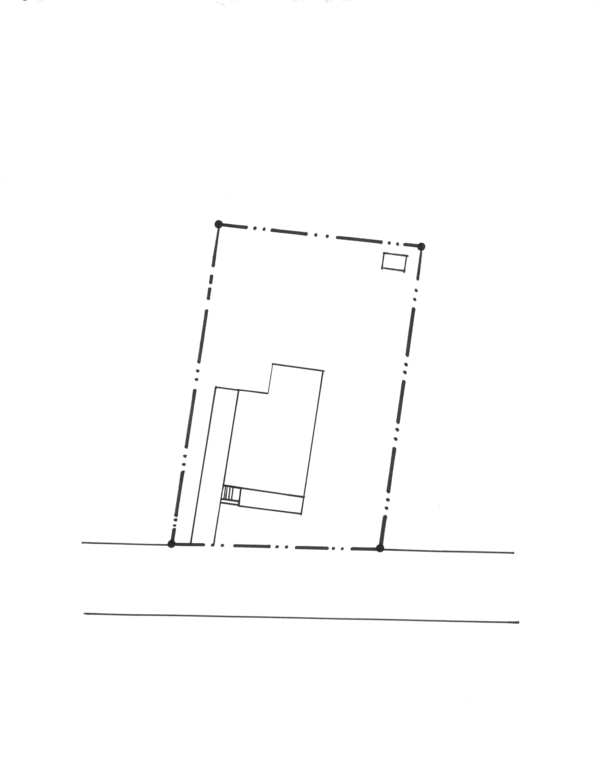
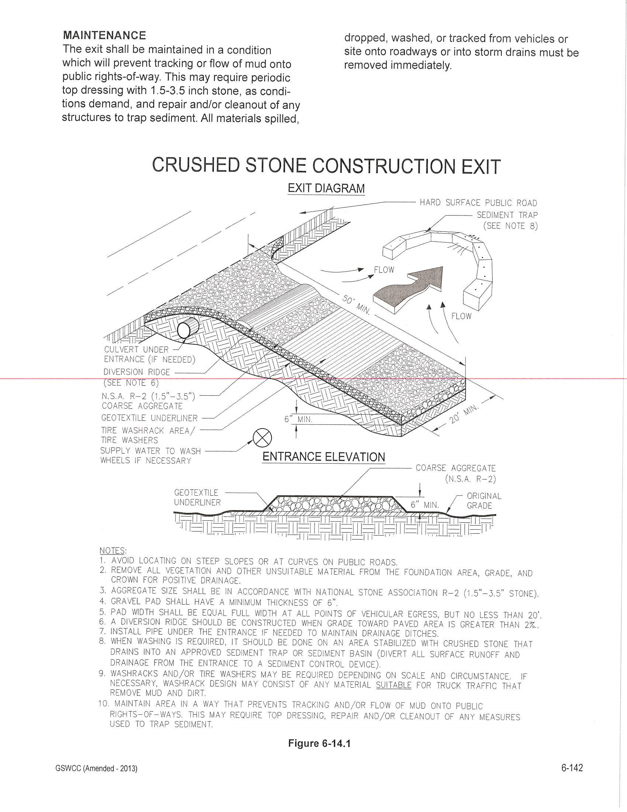
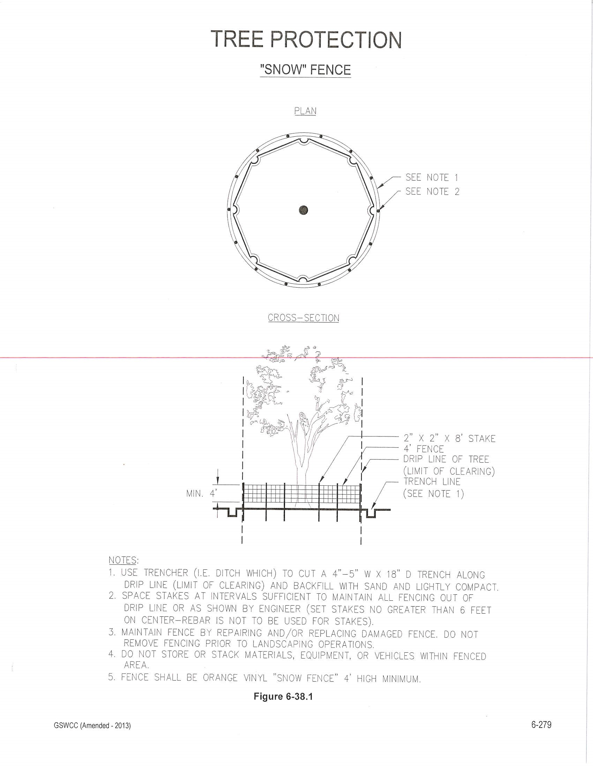

SECTION 02050
DEMOLITION OF EXISTING STRUCTURES
PART 1 - GENERAL
1.01 DESCRIPTION
A. Scope of Work
  - This Section specifies the labor, materials, equipment, and incidentals required for the demolition, relocation, and/or disposal of all structures, building materials, equipment, and accessories to be removed as shown on the Drawings and as specified herein.
  - There may be existing and active stormwater, wastewater, water, and other facilities on site as indicated on the Drawings. It is essential that these facilities, when encountered, remain intact and in service during the proposed demolition. Consequently, the Contractor shall be responsible for the protection of these facilities and shall diligently direct all his activities toward maintaining continuous operation of the existing facilities and minimizing operational inconvenience.
  - Demolition generally includes:
    - Complete demolition and removal of manholes, valve vaults, wetwells, piping, and mechanical and electrical equipment related to the Work as shown on the Drawings and specified herein.
    - Complete demolition and removal of all above and below ground structures, concrete slabs and foundations, vaults, and underground utilities (water, wastewater, electrical, etc.) as shown on the Drawings and specified herein.
    - All material, equipment, rubble, debris, and other products of the demolition shall become the property of the Contractor for his disposal off-site in accordance with all applicable laws and ordinances at the Contractor's expense. The sale of salvageable materials by the Contractor shall only be conducted off-site. The sale of removed items on the site is prohibited by the City of Decatur.
  - The Contractor shall examine the various Drawings, visit the site, determine the extent of the Work, the extent of work affected therein, and all conditions under which he is required to perform the various operations.
  - The Contractor shall fill and compact all voids left by the removal of pipe, structures, etc. with materials described herein to a grade that will provide for positive drainage of the disturbed area to drain run-off in direction consistent with the surrounding area. The Contractor shall provide all fill materials to the site as needed. Compaction of fill shall match the compaction of adjacent undisturbed material.
1.02 QUALITY ASSURANCE
- Permits and Licenses:
- Contractor shall obtain all necessary permits. Permits will be provided to Contractor by
the City of Decatur at no cost to the Contractor
- Licenses for performing the Work. The Contractor shall have a current business license issued by a city or county within the State of Georgia.
- Notices: Per City Ordinance, The Design, Environment, and Construction division shall post the property for a period not to exceed 15 days. Until such time the notice of demolition delay has expired, no demolition activities shall take place on the premises
- Utility Services: Contractor shall notify utility companies or local authorities furnishing gas, water, electrical, telephone, or sewer service to remove any equipment in the structures to be demolished and to remove, disconnect, cap, or plug their services to facilitate demolition.
- Hazardous Materials Abatement: The Contractor shall engage a certified hazardous materials abatement company to properly remove and dispose of the hazardous materials on site. A copy of the hazardous materials survey(s) has been included as an attachment to this specification
1.03 SUBMITTALS
- Submittals shall be submitted to the City of Decatur prior to commencing with the Work contained within the submittal requiring action
- Provide a detailed sequence of demolition and septic system removal work . Include in the schedule the coordination of hazardous materials abatement, utilities shut-off, and capping, utility services as required.
- Before commencing structure demolition work the following items shall be completed
    - Attend a Pre-Demolition Conference with City of Decatur Staff
    - All erosion and sedimentation control measures shall be installed and inspected by the
City of Decatur Engineering Inspector
    - Removal and/or capping of sewer/ utilities complete.
    - A letter from a certified pest control company shall be submitted to this office
    - A Hazardous materials abatement complete
    - Actual work will not begin until the City of Decatur has inspected and approved the prerequisite work and authorized commencement of the demolition work.
1.04 SITE CONDITIONS
- The City of Decatur assumes no responsibility for the actual condition of the structures to be demolished or relocated.
- Conditions existing at the time of inspection for bidding purposes will be maintained by the City of Decatur insofar as practicable. However, variations within each site may occur prior to the start of demolition work.
- No additional payment will be made for pumping or other difficulties encountered due to water.
- Certain information regarding the reputed presence, size, character and location of existing underground structures, pipes and conduit has been shown on the Drawings. There is no certainty of the accuracy of this information, and the location of underground structures shown may be inaccurate and other obstructions than those shown may be encountered. The Contractor hereby distinctly agrees that the City of Decatur is not responsible for the correctness or sufficiency of the information given; that in no event is this information to be considered as a part of the Contract; that he shall have no claim for delay or extra compensation on account of incorrectness of information regarding obstructions either revealed or not revealed by the Drawings; and that he shall have no claim for relief from any obligation or responsibility under this Contract in case the location, size, or character of any pipe or other underground structure is not as indicated on the Drawings, or in case any pipe or other underground structure is encountered that is not shown on the Drawings.
1.05 RESTRICTIONS
- No building, tank or structure, or any part thereof, shall be demolished until the permit has been issued by the City of Decatur. Demolition shall be in accordance with applicable provisions of the Building Code of the State of Georgia and the Ordinances of the City of Decatur.
- No explosives shall be used at any time during the demolition. No burning of combustible material will be allowed.
- All Work shall be restricted to the Hours listed below, per City Ordinance
    - 7:00 a.m. to 6:00 p.m. Monday through Friday
    - No Work on Saturday, Sunday or Holidays
1.06 DISPOSAL OF MATERIAL
- All salvageable or useable material or equipment to be retained by the City of Decatur shall be shown on Drawings or listed below, and shall be moved to a designated area by Contractor for pick up by City of Decatur. The Contractor shall promptly remove all other materials from the site as indicated or shown on the Drawings.
- All materials not retained by the City of Decatur shall become the Contractor's property and shall be removed off-site.
- The on-site storage of removed items is prohibited by the City of Decatur. Off-site sale of salvageable material by the Contractor is acceptable.
1.07 TRAFFIC AND ACCESS
- An approved Construction Entrance / Exit shall be installed prior to Demolition Activities. Refer to Detail “CO” in the demolition drawing plans
- Conduct Work to ensure minimum interference with on-site and off-site roads, streets, sidewalks, and occupied or used facilities. If work is required in the city Right of Way, a right of Way Permit is required and may be obtained from the City of Decatur. There are no fees associated with obtaining Right of Way Permits on City of Decatur projects
- Do not close or obstruct streets, sidewalks, or other occupied or used facilities without permission from the City of Decatur. Provide alternate routes around closed or obstructed traffic in access ways.
- The adjacent parking lot on private property shall not be used for entry, access, transport or parking related to the activities within this scope of work
1.08 PROTECTION
A. Conduct operations to minimize damage by falling debris or other causes to adjacent buildings, structures, roadways, other facilities, and persons. Provide interior and exterior shoring, bracing, or support as required to prevent movement or settlement or collapse of structures to be demolished and adjacent facilities to remain.
1.09 DAMAGE TO CITY OR PRIVATE PROPERTY
- Promptly repair damage caused to city and private property by demolition operations as directed by the Property Owner effected and/or the City of Decatur at no cost to the City of Decatur. This includes but is not limited to:
    - Structures
    - Buildings
    - Streets, bridges, abutments, retaining walls
    - Sidewalks, curbs, driveways and aprons
- A pre-demolition inspection and a post demolition inspection will be completed. Damage to City or Private property shall be completed at the Contractor’s Expense

1.10 UTILITIES
- Do not interrupt existing utilities serving occupied or operational facilities..
- The Contractor shall cooperate with applicable utilities to shut off, cap, and disconnect services serving structures of the existing facilities as required by demolition operations.
- The Contractor shall be solely responsible for making all necessary arrangements and for performing any necessary work involved in connection with the interruption of all public
and private utilities or services.
- Water utilities being abandoned shall be terminated at the property line near the entry point from the Right of Way
- The existing Septic System, including all tanks, piping and \shall be removed entirely. Absorption field piping shall be abandoned in place.
1.11 EXTERMINATION
A. A letter clearing the property of rodent infestation shall be completed by the City of Decatur prior to the demolition inspection.
1.12 POLLUTION CONTROL
- For pollution control, use water sprinkling, temporary enclosures, and other suitable methods as necessary to limit the amount of dust rising and scattering in the air to the lowest level of air pollution practical for the conditions of work. The Contractor shall comply with the governing regulations.
- Clean adjacent structures and improvements of all dust and debris caused by demolition operations as directed by the City of Decatur. Return areas to conditions existing prior to the start of Work.
1.13 TREE REMOVAL
A. Tree Removal is not permitted by City Ordinance and will be contracted separately by others
1.14 FINAL GRADING AND STABILIZATION
- Final Grading: As required, the contractor shall grade the site as required to prevent the collection of water and to prevent the flow of storm water to adjacent properties
- The Construction Entry/ Exit shall be removed
- Soils and Backfill: If final grading cannot be completed as described above without additional soils, the City of Decatur shall provide soils and the transport of soils to the site at no cost to the contractor.
- The Contractor shall seed and straw the site with shade resistant rye mixture grass intended for winter installations. The Contractor shall leave the erosion and sediment control measures on site after the final inspections and will be removed by the City of Decatur after project final completion at such time the grass is 70% established.
1.15 PROJECT SUBSTANTIAL COMPLETION
A. Final Completion shall be defined as:
  - Demolition activities complete
  - Construction Entry/ Exit Removed
  - Repairs and cleaning completed to public and private property that may have been damaged/effected during demolition operations
  - Final Grading and Stabilization
  - Only after the site has been final inspected by the City of Decatur, will the project be deemed “Substantially Complete”.
PART 2 - PRODUCTS (NOT USED)
PART 3 - EXECUTION
3.01 SEQUENCE OF WORK
A. The sequence of demolition and relocation of existing facilities shall be in accordance with the approved schedule as specified in paragraph 1.03 above.
3.02 DEMOLITION PROCEDURES
The Contractor shall adhere to the following demolition procedures as referenced on the Drawings:
TO BE DEMOLISHED: Demolition shall be the breaking up, cutting, filling of any holes resulting, final grading of the area, performing any other operations required, and the removal from the site of all structures and equipment (structures, substructures, floor slabs, equipment, tanks, pipes, fittings, electrical systems, light poles, wiring, underground conduits and wiring, isolated slabs, and sidewalks) as indicated on the Drawings.
Before commencing structural demolition, remove all mechanical, electrical, piping, and miscellaneous appurtenances. Completely remove the structure by thoroughly breaking up concrete and masonry and properly disposing off site at an approved location
- TO BE PROTECTED: Where indicated on the Drawings, the structure, tree, or device so designated shall be temporarily protected during the prosecution of the demolition work as specified
- TO REMAIN: Where indicated on the Drawings, the designated items shall remain intact and in service during the prosecution of the demolition work.
3.03 SEPTIC SYSTEM REMOVAL
- The Contractor shall properly pump the existing septic system prior to removal of tanks.
- The Contractor shall notify DeKalb County Health department and notify authorities having jurisdiction that the septic system is to be removed.
- The Contractor shall properly remove and discard the existing tanks, and abandon the existing absorption field lines in place
- Excavation shall be completed so as to minimize damage to trees and adjacent property.
- The contractor shall be responsible for obtaining clean fill to backfill locations.
3.04 GRADING AND SEEDING
- The site shall be graded and seeded by the contractor. Prior to seeding all fill shall be properly compacted so as to reduce sinking and erosion
- The contractor shall obtain clean fill from the City of Decatur as required. Coordinate locations where clean fill may be obtained. The Contractor shall be responsible for transport of clean fill to the project site.
- The site shall be seeded and strawed. Seed shall be a “winter mix” of tall fescue or similar shade grasses. Upon application of the seed, straw shall be placed on top of seeded areas
- Erosion and Sediment Control measures shall remain and removed by the City of Decatur when the grass has been established.
END OF SECTION

